**CLUB VESTS AND CROP TOPS**

Club vests and crop tops are available from the clubhouses at Rugby and Moulton. Other items of club kit can be ordered online from our suppliers, Webb Ellis and Kukri.



**CLUB HOODIES**

Club hoodies can be ordered from Webb Ellis using [this link](https://webbellisrugby.co.uk/product-category/club-shop/rugby-northampton-athletic-club/). See below the size chart for club hoodies.

|  |  |  |  |  |  |  |  |  |  |  |
| --- | --- | --- | --- | --- | --- | --- | --- | --- | --- | --- |
| 5XS | 4XS | 3XS | XXS | XS | S | M | L | XL | XXL | 3XL |
| 24" | 26/28" | 30" | 32" | 34" | 36" | 38"/40" | 42" | 44" | 46" | 48/50" |

When ready, the hoodies can be collected from the Webb Ellis shop, which is opposite Rugby School (5 & 6 St. Matthews Street, Rugby, CV21 3BY). Alternatively, if more convenient, enter “COLLECTION AT CLUB” in the “order notes” box on the Checkout page and the Club will arrange to pick up the hoodie, which can then be collected from the Moulton or Rugby clubhouse, as applicable.

**OTHER CLUB KIT**

Other club kit can be ordered from Kukri using [this link](http://www.kukrisports.co.uk/teamshop/rugbynorthamptonathleticclub). Here is a size guide for the different age groups and genders for kit supplied by Kukri.

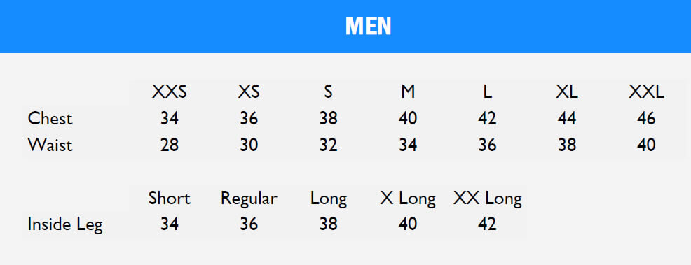

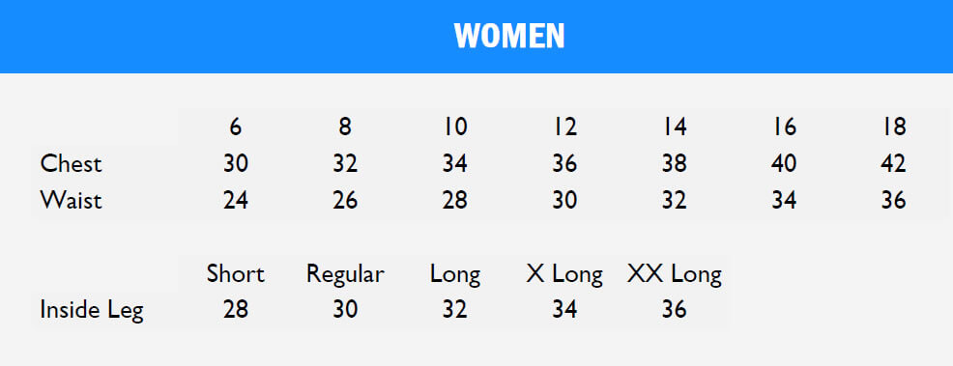

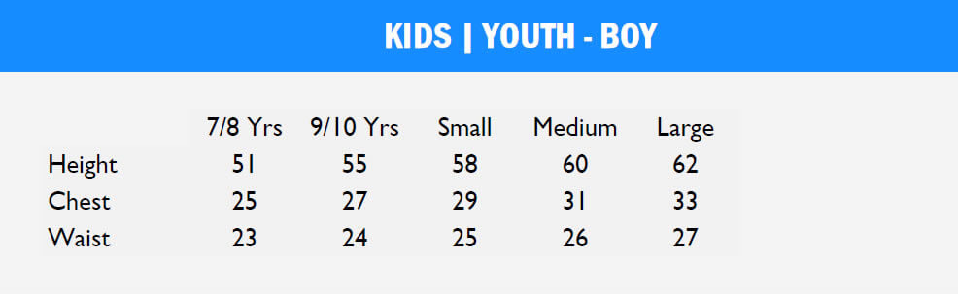

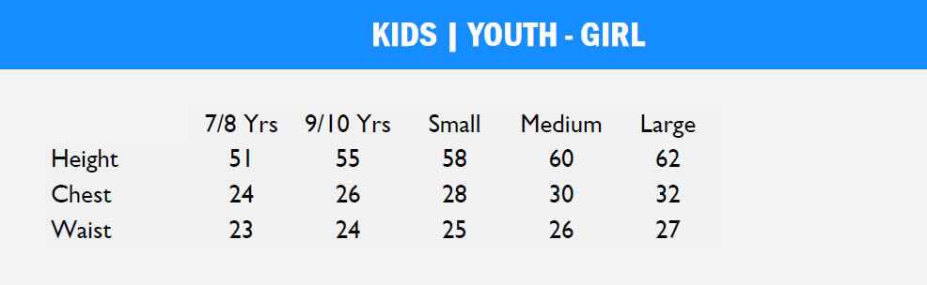

PLEASE NOTE

All sizes for Kukri garments are based on body measurements, with the exception of the Inside Leg, which is based on the garment measurement. All measurements are stated in inches.