Midland Women’s Cross-Country League – 1.30 p.m.
Birmingham & District Invitation Cross-Country League – 2.30 p.m.
Betley Court Farm, Main Road, Betley, Crewe, CW3 9BH
Saturday 13th November 2021
Directions to the venue supplied by the host club are attached together with the course map. Please note the recommendation that those using the M6 should leave at Junction 16 even though your SatNav may try to take you off at Junction 15.
Directions
Betley lies to the West of the M6, above J15 and just below J16. It is more straightforward to come off at J16 as it only involves a couple of roads and roundabouts and is through open countryside whereas coming from J15 involves navigating around the suburbs of Newcastle-Under-Lyme. These directions are based on reaching the Junctions from the south.
From J16 M6
• At junction 16 take the 1st exit - A500 signed to Nantwich/Crewe – continue for 2.1 miles
• At next roundabout take the 1st exit onto A531 - continue for 1.0 miles
• At the next roundabout, take the 1st exit onto Newcastle Rd/A531 - continue for 0.4 miles
• At the roundabout, take the 2nd exit and stay on Newcastle Rd/A531
• Continue to follow A531 - 2.3 miles to Betley.
• Travel straight through the village past a large building (Betley Court) which is heavily scaffolded and covered due to renovation.
• Destination will be on the right – Betley Court Farm, Betley, Crewe CW3 9BH
From J15 M6
•At junction 15, take the A500 signed to Stoke-on-Trent/Newcastle-under-Lyme
• At the roundabout, take the 1st exit onto Newcastle Rd/A519. Continue to follow A519 – continue for 0.5 miles
• At the next roundabout, take the 2nd exit onto Clayton Rd/A519 - continue for 0.8 miles
• At the next roundabout, take the 1st exit onto Dartmouth Ave - continue for 0.7 miles
• At the next roundabout, take the 2nd exit onto Sneyd Ave - continue for 0.5 miles
• At the T Junction turn left onto Gallowstree Ln - continue for 0.4 miles
• At the roundabout, take the 1st exit onto Keele Rd/A525 - continue for 0.3 miles
• At the next roundabout take the 2nd Exit - continue for 5 miles (A525/A531)
• Destination will be on the left – Betley Court Farm Betley, Crewe CW3 9BH

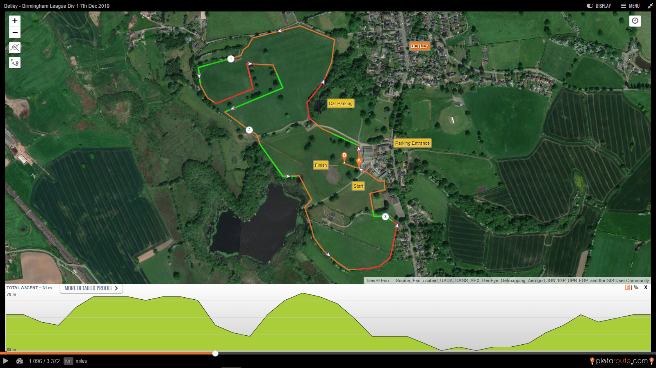

The Women’s race is 2 laps and the Men’s race 3 laps

